Question 1)

Adjacency matrix representation of figure 1.

|  |  |  |  |  |  |  |  |  |
| --- | --- | --- | --- | --- | --- | --- | --- | --- |
|  | S | A | B | C | D | E | F | G |
| S | 0 | 3 | 2 | ∞ | ∞ | ∞ | ∞ | ∞ |
| A | ∞ | 0 | ∞ | ∞ | 1 | 2 | ∞ | ∞ |
| B | 3 | 2 | 0 | ∞ | 1 | ∞ | ∞ | ∞ |
| C | ∞ | ∞ | 4 | 0 | ∞ | ∞ | ∞ | ∞ |
| D | ∞ | ∞ | ∞ | ∞ | 0 | 1 | 2 | 2 |
| E | ∞ | ∞ | ∞ | ∞ | ∞ | 0 | 2 | 3 |
| F | ∞ | ∞ | ∞ | 1 | ∞ | ∞ | 0 | ∞ |
| G | ∞ | ∞ | ∞ | ∞ | ∞ | ∞ | 2 | 0 |

|  |  |  |  |  |  |  |  |  |  |
| --- | --- | --- | --- | --- | --- | --- | --- | --- | --- |
| STEP | VERTEX | S | A | B | C | D | E | F | G |
| 1 | S(0) | 0  S | 3  S | 2  S | ∞ | ∞ | ∞ | ∞ | ∞ |
| 2 | B(2) | 0  S | 3  S | 2  S | ∞ | 3  B | ∞ | ∞ | ∞ |
| 3 | A(3) | 0  S | 3  S | 2  S | ∞ | 3  B | ∞ | ∞ | ∞ |
| 4 | D(3) | 0  S | 3  S | 2  S | ∞ | 3  B | 4  D | 5  D | 5  D |
| 5 | E (4) | 0  S | 3  S | 2  S | ∞ | 3  B | 4  D | 5  D | 5  D |
| 6 | G (5) | 0  S | 3  S | 2  S | ∞ | 3  B | 4  D | 5  D | 5  D |
| 7 | F(5) | 0  S | 3  S | 2  S | 6  F | 3  B | 4  D | 5  D | 5  D |
| 8 | C(6) | 0  S | 3  S | 2  S | 6  F | 3  B | 4  D | 5  D | 5  D |

|  |  |
| --- | --- |
| Vertex | Distance from S |
| S | 0 |
| a | 3 |
| B | 2 |
| C | 6 |
| D | 3 |
| E | 4 |
| f | 5 |
| g | 5 |

Q2) Undireccted



Cost = S->B->D->E->F->C->G->A

2+1+1+2+1+3+2=12

Q3) Undirected



Q4)

S -> A -> B -> D -> E -> F -> G -> C

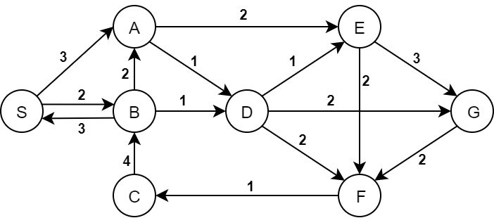



























Q5)Part A

S -> A -> D -> E -> F -> C -> B -> G

























Part B && C of Q5

|  |  |  |
| --- | --- | --- |
|  | PRE | POST |
| S | 1 | 16 |
| A | 2 | 15 |
| D | 3 | 14 |
| E | 4 | 13 |
| F | 5 | 10 |
| C | 6 | 9 |
| B | 7 | 8 |
| G | 11 | 12 |

Q5 PART D)

Tree arcs





Forward arcs





Backward Arcs





Cross Edge





Q6)

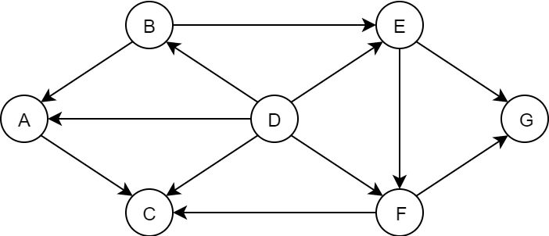

TOPOLOCİGAL ORDER : D->B ->E->F->G->A->C